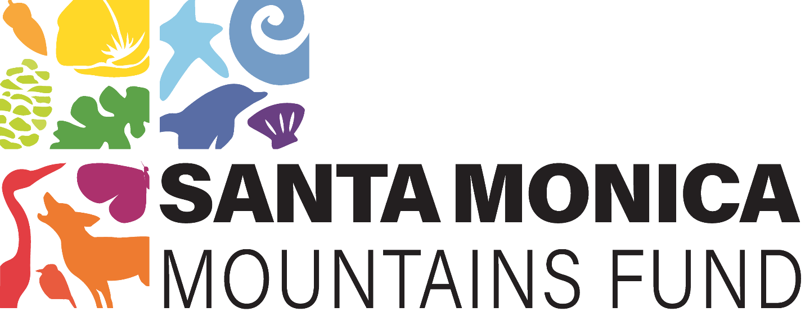

Coloring Book Curricula
–
Kindergarten to Grade 5

Support Our Mission
We are delighted to provide these curriculum materials free of charge. However, as a fundraising organization, the Santa Monica Mountains Fund relies on donations to support our mission of preserving and protecting the Santa Monica Mountains National Recreation Area. If you find value in these materials, please consider making a donation to help us continue our important work. Your support is greatly appreciated.

PRE-KINDERGARTEN

Standards: California Preschool Learning Foundations

INTRODUCTION TO NATURE

- Coloring Pages: Trees, flowers and animals found in the Santa Monica Mountains.
- Activities: Simple identification of colors and shapes in nature
- Learning Objectives: Develop awareness of the natural environment and basic vocabulary.
- Color Therapy: Use bright, warm colors (yellow, red, orange, etc.) to evoke feelings of happiness and excitement. Encourage students to choose colors that make them feel good.

KINDERGARTEN

Standards: California Common Core State Standards (CCSS)

EXPLORING WILDLIFE

- Coloring Pages: Animals like coyotes, bobcats and birds.
- Activities: Matching animals to their habitats
- Learning Objectives: Recognize and name commons animals, understand basic needs of living things.
- Color Therapy: Use cool colors (blue, green, purple, etc.) to create a calming effect. Discuss how different colors make them feel good and encourage them to choose colors based on their emotions.

FIRST GRADE

Standards: California CCSS

PLANT LIFE

- Coloring Pages: Native plants like oak trees, wildflowers and shrubs.
- Activities: Labeling parts of a plant, simple plant lifecycle.
- Learning Objectives: Identify parts of a plant and understand their functions.
- Color Therapy: Incorporate a variety of colors to stimulate creativity and interest. Ask students to color plants with their favorite colors and explain why they chose them.

SECOND GRADE

Standards: California CCSS

ECOSYSTEMS

- Coloring Pages: Different habitats within the Santa Monica Mountains (forests, grasslands, streams).
- Activities: Drawing connections between animals and their habitats.
- Learning Objectives: Understand the concept of ecosystems and interdependence of organisms.
- Color Therapy: Use earth tones (browns, greens, dark yellows, etc.) to promote a sense of grounding and connection to nature. Encourage students to reflect on how these colors make them feel calm and connected.

THIRD GRADE

Standards: California CCSS

HISTORY AND CULTURE

- Coloring Pages: Chumash Native American artifacts, early explorers and settlers.
- Activities: Creating timelines and mapping activities.
- Learning Objectives: Learn about the history of the Santa Monica Mountains and the people who lives there.
- Color Therapy: Use historical colors (red, orange, brown, etc.) to evoke a sense of warmth and curiosity about the past. Discuss how these colors might represent different aspects of history culture.

FOURTH GRADE

Standards: California CCSS

GEOGRAPHY AND GEOLOGY

- Coloring Pages: Mountain ranges, rock formations and maps.
- Activities: Identifying geographic features and understanding geographical processes.
- Learning Objectives: Develop map reading skills and understand basic geological concepts.
- Color Therapy: Use a combination of bright and muted colors to balance excitement and focus. Encourage students to think about how colors can highlight geographic features.

FIFTH GRADE

Standards: California CCSS

CONSERVATION AND ENVIRONMENTAL PROTECTION

- Coloring Pages: Endangered species, conservation efforts and park rangers.
- Activities: Research projects on conservation methods, creating posters.
- Learning Objectives: Understand the importance of conservation and how to protect natural resources.
- Color Therapy: Use soothing colors (blues, greens, purples, etc.) to inspire thoughts of peace and preservation. Discuss how these colors can symbolize a healthy environment and the importance of conservation.

ADDITIONAL RESOURCES

- Teacher Guides: Include background information, additional activities and discussion questions.
- Field Trips: Suggestions for visiting the Santa Monica Mountains National Recreation Area.
- Digital Resources: Links to videos and interactive websites about the Santa Monica Mountains.
- Color Therapy Tips: Explore tips on incorporating color therapy into lessons, such as using specific colors to create a positive learning environment.

IMPLEMENTATION

- Integration: Align coloring book activities with classroom lessons.

Disclaimer
The curriculum materials provided by the Santa Monica Mountains Fund are intended for educational purposes only. While we strive to ensure the accuracy and reliability of the information contained within these materials, the Santa Monica Mountains Fund makes no guarantees, express or implied, regarding the completeness, accuracy, or reliability of the information.

Use of Materials
By using these materials, you agree to use them solely for non-commercial, educational purposes. You may reproduce and distribute the materials for educational purposes, provided that appropriate credit is given to the Santa Monica Mountains Fund.

No Endorsement
Reference to any specific commercial product, process, service, or company does not constitute its endorsement or recommendation by the Santa Monica Mountains Fund. The views and opinions expressed in the curriculum materials do not necessarily state or reflect those of the Santa Monica Mountains Fund.

Liability
The Santa Monica Mountains Fund shall not be liable for any errors or omissions in the materials nor for any loss, injury, or damage caused, either directly or indirectly, by the use or reliance on these materials. Users are encouraged to verify any information used from the materials.

External Links
The curriculum may contain links to external websites. The Santa Monica Mountains Fund is not responsible for the content or privacy practices of such sites and encourages users to review the privacy policies of these websites.

Modifications
The Santa Monica Mountains Fund reserves the right to modify or discontinue, temporarily or permanently, any part of the curriculum materials with or without notice.

Acceptance of Terms
By using the curriculum materials provided by the Santa Monica Mountains Fund, you signify your acceptance of this disclaimer. If you do not agree to this disclaimer, please do not use the curriculum materials.

